**3. Power factor improvement. Power measurement of single-phase receivers**

3.2. Laboratory tests

**3.2.1.** Power measurement of single phase receiver

The active power of the single-phase receiver shall be measured by using the active energy meter and the wattmeter in the system presented in Fig. 3.7.

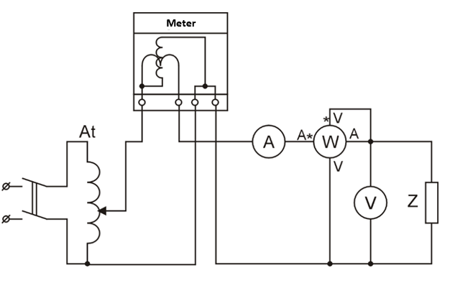

**Figure 3.7.** System for measuring the active power of a single phase receiver

At - autotransformer, A - ammeter, W - wattmeter, V - voltmeter

Measurements carried out for different receivers. The results of the measurements and calculations write in table 3.1.

Provide examples of calculations according to formula 3.22.

Based on the results of measurements and calculations, draw a phasor graph of currents and voltages for each type of receiver.

**Table 2. 3.1.**

|  |  |  |  |  |  |  |  |  |  |  |  |  |
| --- | --- | --- | --- | --- | --- | --- | --- | --- | --- | --- | --- | --- |
| Receiver | UV | Ia | PL | | | PW | | | S | Q | cosϕ | ϕ |
| N | Δt | PL | α | KW | PW |
| V | A | - | S | W | plots | W/plots | W | VA | var | - | deg |
| R |  |  |  |  |  |  |  |  |  |  |  |  |
| R |  |  |  |  |  |  |  |  |  |  |  |  |
| L |  |  |  |  |  |  |  |  |  |  |  |  |
| C |  |  |  |  |  |  |  |  |  |  |  |  |
| Rl |  |  |  |  |  |  |  |  |  |  |  |  |

3.2.2. Power factor improvement

Perform measurements of voltages, currents and power without capacitor and with the switch on capacitor in the system shown in Fig. 3.8.

Measurements performed with open and closed circuit breaker for different capacitor capacity values. The results of the measurements and calculations write in table 3.2. Provide examples of calculations according to the following formulas:

, 

 Or 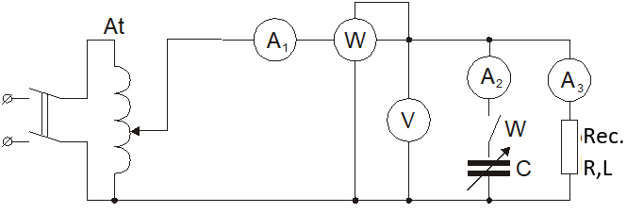

**Figure 3.8.** Power factor improvement system

A1, A2, A3 - ammeter, V- voltmeter, W - wattmeter,

C - capacitor, Rec. R, L - receiver

Based on the results of measurements and calculations, perform an phasor graph of currents and voltages for each test system.

Note: the R, L receivers are a serial connection of R and L elements.

**Table 3.2**

|  |  |  |  |  |  |  |  |  |  |  |  |  |
| --- | --- | --- | --- | --- | --- | --- | --- | --- | --- | --- | --- | --- |
| No. | Uv | I1 | I2 | I3 | PW | | | cosϕ | cosϕ' | ϕ | ϕ' | C |
| α | KW | PW |
| V | A | A | A | plots | W/plots | W | - | - | deg | deg | μF |
| 1 |  |  |  |  |  |  |  |  |  |  |  |  |
| 2 |  |  |  |  |  |  |  |  |  |  |  |  |
| 3 |  |  |  |  |  |  |  |  |  |  |  |  |
| 4 |  |  |  |  |  |  |  |  |  |  |  |  |
| 5 |  |  |  |  |  |  |  |  |  |  |  |  |