**42.** **Direct current.**

**Laws, theorems, calculation methods**

**42.2. Laboratory tests**

**42.2.1** Ohm's law

Connect the layout **1**. on the training board (Fig.42.6). To do this connect ammeter and voltmeter to the system and freely selected resistor from the set of resistors located on the training board. Connect the voltage to the circuit number **1** and next by adjusting the voltage source potentiometer, perform measurements and plot the characteristics $\text{U=f}\left(I\right)$ for the selected resistor. Note the measurement results in table 42.1.

**Table 42.1.**

|  |  |  |  |
| --- | --- | --- | --- |
| No. | U | I | R |
| V | mA | Ω |
|  |  |  |  |
|  |  |  |  |
|  |  |  |  |
|  |  |  |  |
|  |  |  |  |
|  |  |  |  |
|  |  |  |  |
|  |  |  |  |
|  |  |  |  |
|  |  |  |  |

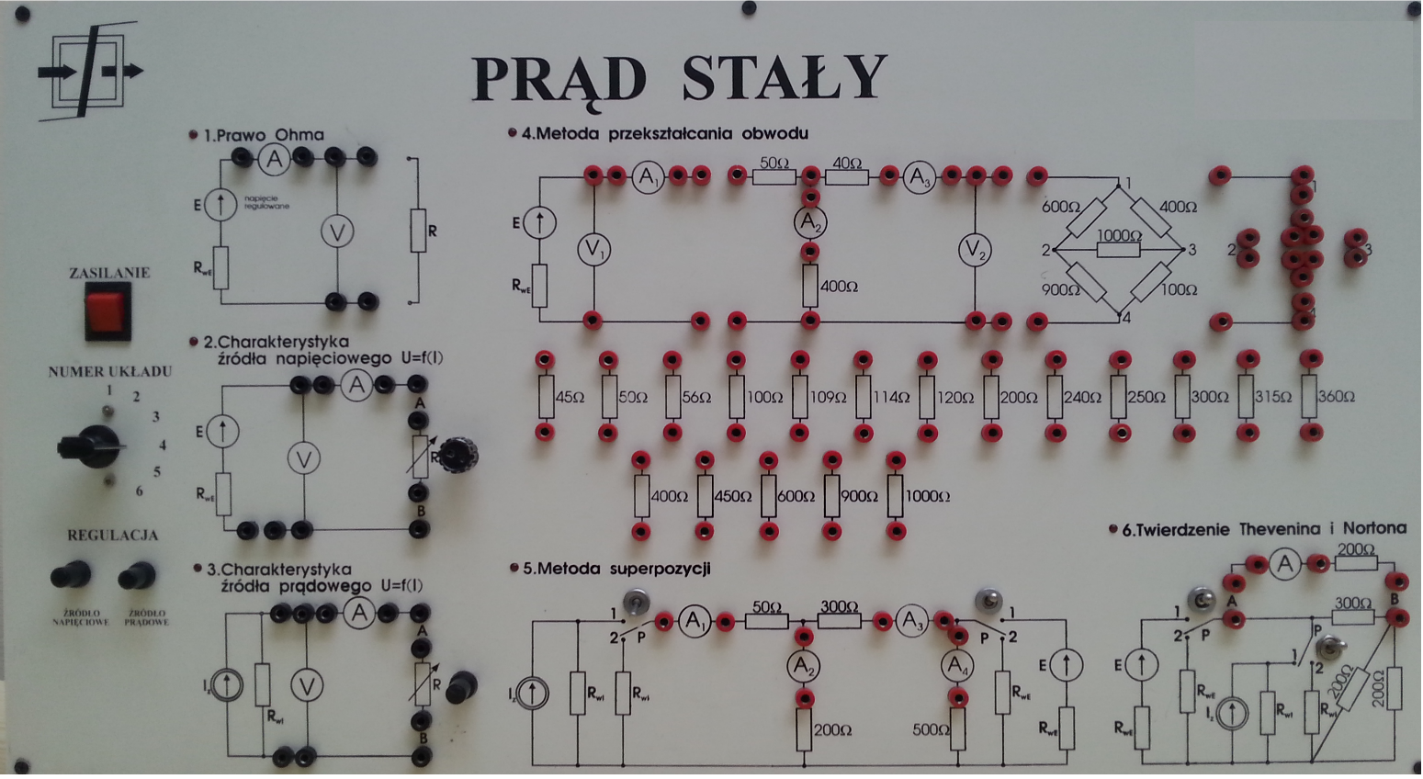

**Figure 42.6.** Training board

**42.2.2.** Characteristics of voltage and current sources

Connect the layout **2** on the training board (Fig. 42.6) (according to Fig. 42.2), leaving the AB terminals open*.* Connect voltage to the circuit **2** . By adjusting the voltage source potentiometer, set the source voltage E = 5 V or E = 2 V. Save the first point in table 2 with the current I equal to zero. Set the adjustable R resistor to the maximum value (right extreme position), connect the resistor to the voltage source AB terminals. Perform a series of measurements, reducing the resistance value from the maximum value to zero. Note the measurement results in table 42.2.

**Table 42.2.**

|  |  |  |
| --- | --- | --- |
| No. | U | I |
| V | mA |
|  |  |  |
|  |  |  |
|  |  |  |
|  |  |  |
|  |  |  |
|  |  |  |
|  |  |  |
|  |  |  |
|  |  |  |
|  |  |  |

Connect the layout **3** on the training board (Fig. 42.6) (according to Fig. 42.2) short the terminals AB. Connect source to circuit **3**. Set the source current IS= 10 mA or IS= 4 mA by adjusting the current source potentiometer. Set the adjustable R resistor to zero (left extreme position). Connect the resistor to the current source AB terminals. Perform a series of measurements by increasing the R resistance value so as to the voltage on the source does not exceed 5V. Note the measurement results in table 42.3.

**Table 42.3.**

|  |  |  |
| --- | --- | --- |
| No. | U | I |
| V | mA |
|  |  |  |
|  |  |  |
|  |  |  |
|  |  |  |
|  |  |  |
|  |  |  |
|  |  |  |
|  |  |  |
|  |  |  |
|  |  |  |

**42.2.3**. Kirchhoff's Laws

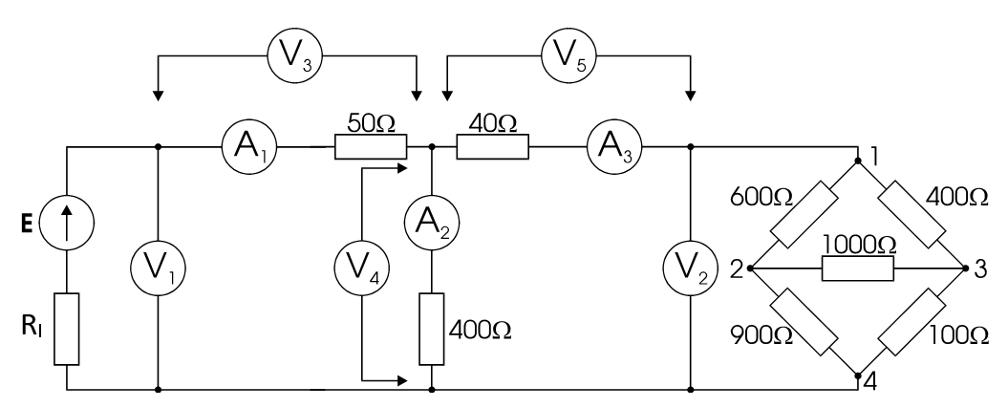

**Figure 42.7.** Basic test circuit

Connect the layout **4** on the training board (Fig. 42.6) (according to Fig. 42.7) connect the meters in the places of the breaks in the circuit connect the jumpers, leaving the source terminals open. Connect the voltage to the circuit **4** and adjust the voltage source by potentiometer to E = 5 V. Connect the jumper connecting the source to the rest of the circuit. Check that the sum of currents in the node is equals zero. Note the results in table 42.4.

**Table 42.4**.

|  |  |  |  |
| --- | --- | --- | --- |
| I1 | I2 | I3 | ∑I |
| mA | mA | mA | mA |
|  |  |  |  |

Check that the sum of the voltages in the closed circuits equals zero, including the additional voltmeter (as shown in Fig. 42.6. ) on branches with resistance 50 Ω, 40 Ω and 400 Ω. Note the results in table 42.5.

**Table 42.5** .

|  |  |  |  |  |  |  |
| --- | --- | --- | --- | --- | --- | --- |
|  |  |  |  |  | Mesh 1 | Mesh 2 |
| U1 | U3 | U4 | U5 | U2 | ∑U | ∑U |
| V | V | V | V | V | V | V |
|  |  |  |  |  |  |  |

**42.2.4.** Method of the circuit transformation

This part of the laboratory studies consists of replacement of the system of resistors with a simpler equivalent system and performing measurements after each change in the system. The results of the measurements shall be noted in table 42.6.

* Perform measurements in the basic layout (Fig. 42.6.)
* Transform part of the circuit **1-4** to equivalent circuit (Fig. 42.6)
* convert



Perform the calculations and assemble the new circuit according to the calculation (using special terminals on the plate and a set of resistors). Detach the basic **1-4** layout and connect the equivalent circuit that is assembled by it. Perform measurements.

* Serial-parallel connection

Calculate the equivalent resistance of the serial-parallel connection and, as calculated, assemble and connect the new circuit. Perform measurements.

* Serial connection

Replace circuit **1-4** with calculated equivalent resistance. Perform measurements.

* Calculate the equivalent resistance of the entire circuit

Replace the entire circuit connected to the source terminals by the resistor calculated by yourself (parallel and serial connections). Values of current I1 and voltage on source U1 note in table 42.6.

**Table 42.6**.

|  |  |  |  |  |  |
| --- | --- | --- | --- | --- | --- |
|  | U1 | I1 | I2 | I3 | U2 |
|  | V | mA | ma | mA | V |
| Primary circuit |  |  |  |  |  |
| 1 equivalent circuit |  |  |  |  |  |
| 2 equivalent circuit |  |  |  |  |  |
| 3 equivalent circuit |  |  |  |  |  |

**42.2.5.** Superposition method

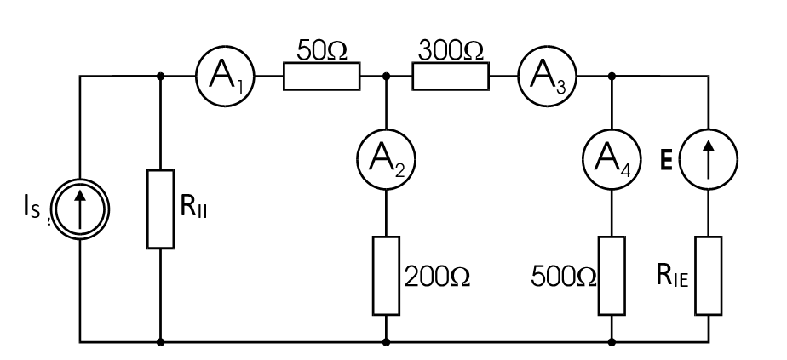

**Figure. 42.8.** Measuring system with two energy sources to validate the application of the superposition method

* Set the source voltage E = 5 V and source current IS= 10 mA. If the positions of voltage and current sources potentiometers are changed:
* Connect the voltmeter to system **2** (Fig. 42.6) (according to Fig. 42.1) on the training board, with the AB terminals and adjusting the voltage source potentiometer, set the source voltage E = 5 V,
* Connect on the ammeter to the system **3** (Fig. 42.6) on the training board (according to Fig. 42.2), with short AB terminals and adjusting the current source potentiometer, set the source current IS = 10 mA,

then

* Connect the meters into system **5** on the training board (Fig. 42.6),
* Set the p-switches to position **1**,
* Connect sources to system **5**.

Perform measurements and note the results in table 42.7.

**Table 42.7**.

|  |  |  |  |  |
| --- | --- | --- | --- | --- |
| Connected | I1 | I2 | I3 | I4 |
| sources: | mA | mA | mA | mA |
| Both simultaneously |  |  |  |  |
| Only voltage |  |  |  |  |
| Only current |  |  |  |  |
| ∑I |  |  |  |  |

* Open the current source, leaving its internal resistance (Fig.42.6- switch p at current source set in position **2**). Perform the measurements, note the results in table 42.7.
* Connect the current source (Fig. 42.6 switch p at current source set to position **1**)
* Short voltage source leaving its internal resistance (Fig.42.6 switch with voltage source in position **2**). Perform the measurements, note the results in table 42.7.

**42.2.6.** Thevenin’s and Norton’s Theorem

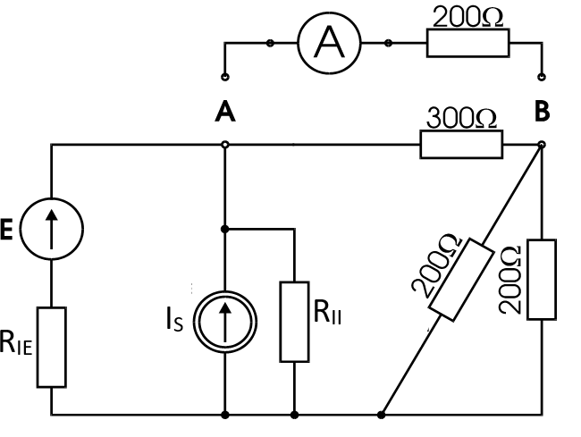

**Figure 42.9.** Measuring system with two energy sources to verify the correctness of Thevenin’s and Norton’s Theorem

* Set the source voltage E = 2 V and source current IS= 4 mA. To do it , proceed as described in point 2.5.
* Set the switches to **1** Fig. 42.6.
* To the terminals AB connect the branch with resistance 200 Ω and ammeter.
* Connect the sources to the system and measure the current I. The measurement results note in table 42.9.
* Open the AB branch.
* Measure by voltmeter the voltage on the AB terminals in the idle state UAB.
* Short the AB terminals with the ammeter and measure the short-circuit current ISAB.
* Turn off the sources from layout 6 on the training board (Fig.4 2.6) (according to Fig 42.9).
* Measure the resistance of the system RAB as seen from the AB terminals.
* Note the measurement results in table 42.8.

**Table 42.8.**

|  |  |  |  |
| --- | --- | --- | --- |
|  | UAB | ISAB | RAB |
|  | V | mA | Ω |
| Measurement |  |  |  |
| Calculations |  |  |  |

* To layout **2** on the training board (Fig. 42.6) in series with RIE enable such resistor so that the created voltage source has a resistance equal to the resistance of RAB measured in system **6** on the training board (Fig. 42.6) (according to Fig. 42.9). Connect the voltmeter, leave the AB terminals open. Connect source to system **2** (Fig. 42.6). Use potentiometer to set the source voltage equal to the voltage UAB.
* AB branch with ammeter and 200 Ω resistor (from **6** layout – Fig. 42.6) connect the actual voltage source with the internal resistance RAB and the source voltage UAB.
* Measure the current flowing through the connected branch. Note the result in table 42.9.
* To system **3** on the training board connect such resistance in parallel, so that the current source has a resistance equal to the resistance of RAB measured in system **6**. Connect the ammeter and short the AB terminals. Connect the source to the system **3**. Use the potentiometer to set the source current equal ISAB.
* Connect the AB branch of layout **6** on the training board to the AB terminals of the actual current source with the internal resistance RAB and the source current equal to ISAB. Measure the current flowing through the connected branch. The measurement result note in table 42.9.

**Table 42.9.**

|  |  |  |  |  |
| --- | --- | --- | --- | --- |
| Current measurement | Thevenin’s | Theorem | Norton’s | Theorem |
| in layout 6 | Calculations | Measurement | Calculations | Measurement |
| mA | mA | mA | mA | mA |
|  |  |  |  |  |

The report shall include:

* Plotted on millimeter paper the characteristics of the tested resistor U = f(I),
* Calculate the resistance value for several points and compare it to the value stated on the plate,
* Plot the characteristic of the voltage source U = f(I),
* Graphically determine the value of the short-circuit current of the voltage source,
* Calculated on the basis of the characteristics of the voltage source, its internal resistance RIE,
* Plot the characteristics of the current source U = f(I),
* By extending the resulting straight to the U axis, graphically designate the voltage value at the current source IS RII
* Calculated on the basis of the current source characteristics, its internal resistance RII
* Provide a review of Kirchhoff's laws,
* Compare the results obtained during the successive phases of the circuit transformation,
* Compare, resulting from the superposition method, the sum of algebraic currents in the branches at the action of each source separately, with the currents flowing in the branches, when both sources operate simultaneously,
* Using measured values UAB; IAB and RAB- present the active component AB in the form of a real voltage source (Thevenin’s Theorem) and the real current source (Norton’s Theorem) and calculate the current in the branch with resistor 200 Ω (note: the ammeter resistance must be taken into account),
* Compare the current calculated on the basis of both theorems with the measurement results,
* Calculate the values of UAB,ISAB and RAB based on layout **6** data and compare with the measured values.

**42.3. Remarks and conclusions**

Assess the correctness of the use of laws, theorems and computational methods in DC circuits.

**References:**

1. Krakowski M.: Theoretical electrical Engineering*.* Vol. 1: line and non-linear circuits, WNT, Warsaw-Poznań 1995
2. Kurdziel R.: Fundamentals of Electrical Engineering, WNT, Warsaw 1972