43. Test of 3-phase systems

43. Laboratory tests.

Diagram of the measuring system for tests of the 3-phase system is presented in Fig. 43.20.
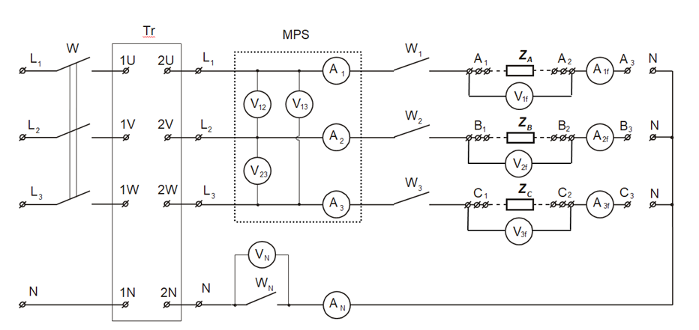

Figure 43.20. Diagram of the measuring system for tests of the 3-phase system

Marks:
V1f, V2f, V3f, VN – digital voltmeter
A1f, A2f, A3f, AN – digital ammeters
W, W1, W2, W3,N – circuit breakers
Z_{A}, Z_{B}, Z_{C} – phase impedances of 3-phase receiver
Tr – 3-phase transformer to decreased the voltage value
MPS – Measuring Parameters System
(line voltages measurement: V12, V13, V23
line currents measurement: A1, A2, A3)

Note: The values of the phase currents should not exceed 1 A due to technical limits resulted of used slide resistors.

43.2.1 Determination of the phase sequence for supply grid

To determine the phase sequence of L₁, L₂, L₃ connect the equivalent phase sequence indicator (the capacitor connect to phase L₁).

43.2.2 Test of the receiver connected in the star.

Between pair of terminal A₁ – A₂, B₁ – B₂, C₁ – C₂ connect phases of receiver Z_{A}, Z_{B}, Z_{C} according to the Fig. 43.21.
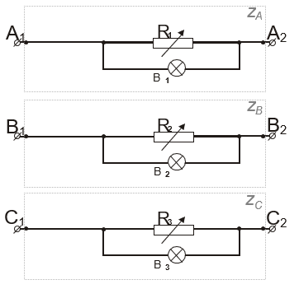
Figure 43.21. Receivers in 3-phase system

Labels: R₁, R₂, R₃ – slide resistors,
B₁, B₂, B₃ – signaling bulbs.

Slide resistors are used as the receiver in the laboratory tests, coupled in parallel with the lighting bulbs. Resistors allow for smooth adjustment of the rms value of the phase currents. Such receivers Z_{A}, Z_{B}, Z_{C} have resistance character.

The receivers have to be connected in the star in the systems (Fig. 43.21), short points A₃, B₃ and C₃ with each other, or by connecting these points with the point N of the receiver (4- wire system).

Measurements shall be performed for all currents, voltages and power in the following cases:

- 4-wire symmetrical system (Switch on: W₁,W₂,W₃,W_{N} and W)
Set resistors to obtain same values of phase currents.

2) 4-wire system with a break in one phase.
Open the switch in the selected phase wire
e.g. W₁. (Switch on: W₂, W₃, W_{N} and W)

3) 3-wire symmetrical system. Switch on W₁.
Open the switch W_{N}. (Switch on: W₁,W₂,W₃ and W)

4) 3-wire system with a break in one phase.
Open the switch in the selected phase line
e.g. W₁. (Switch on: W₂,W₃ and W)

5) 3-wire system with short circuit in one phase.
Open the switches: W, W₁,W₂,W₃. Using wire short selected receiver.
e.g. A₁ with A₂. Make sure that the switch W_{N} is not closed. Power on. (Switch on: W₁,W₂,W₃ andi W)).

The results of the measurements note in table 1a and 1b.
Line values of currents and voltages read from the Measuring Parameters System (MPS), and voltmeter V_{N} and ammeter A_{N.}
The phase values of the current and voltage of the receiver read from voltmeters V_{1f} , V_{2f} , V_{3f} and ammeters A_{1f} , A_{2f} , A_{3f} .
The power values retrieved by the receivers are read from Measuring Parameters System (MPS)
Table 1a.
 | U₁₂ | U₂₃ | U₃₁ | U_{N} | I₁ | I₂ | I₃ | I_{N}
 | [V] | [V] | [V] | [V] | [A] | [A] | [A] | [A]
1.
2.
3.
4.
5.
Line parameters

Table 1b.
 | U_{1P} | U_{2P} | U_{3P} | I_{1P} | I_{2P} | I_{3f} | P_{1P} | P_{2P} | P_{3P}
 | [V] | [V] | [V] | [A] | [A] | [A] | [W] | [W] | [W]
1.
2.
3.
4.
5.
Phase parameters

Based on obtained results:
- desrcibe the relationship between the phase and line voltages of the symmetrical system,
- calculate the impedance of load of each phase,
using the following formulas:
$Z_{P}=\frac{U_{P}}{I_{P}}$ , $φ_{P}\text{=arccos}\frac{P_{P}}{U_{P}\text{×}{\text{I}}_{P}}$ , (43.36)
where:
P_{P} - measured power values, or values calculated from the formula: $P_{P}=U_{P}×I_{P}$
for load with resistance character (cosϕ= 1),
U_{P} -indication of the voltmeter measuring voltage at the load of the selected phase,
I_{P} -indication of the ammeter measuring current of the selected load phase,
Z_{P} -module of the total load impedance of the selected phase,
_{P} -the angle between the voltage and current indication of the selected phase.

- draw phasors diagrams of voltages and currents for the measuring points selected by the teacher.

Results of the calculation note in table 2 and provide example calculations.

Table 2.
A summary of the calculation results for the receiver connected in the star.
 | Z A | A | Z B | B | ZC | C
 | [] | [ ] | [] | [ ] | [] | [ ]
1.
2.
3.
4.
5.
43.2.3 Test of the receiver connected in the delta .
The receivers have to be connected in the delta in the systems (Fig. 43.21) by short the corresponding points. Since there may be two possibilities to connect to the delta - you need to note which points were connected (e.g. ammeter A_{1f} can measure current I₁₂ or I₁₃). For proper operation of the MPS meter, it is necessary to switch of W_{N}.
Measurements shall be performed for all currents, voltages and power in the following cases:

- 3-wire symmetrical system.
Set the same values for the phase currents. (Switch on: W₁,W₂,W₃ and W)

- 3-wire system with break in one phase. Open the switch in the selected phase line e.g. W₁. (Switch on: W₂,W₃ and W)

The results of the measurements note in table 3a and 3b:

Table 3a.
 | U₁₂ | U₂₃ | U₃₁ | I₁ | I₂ | I₃
 | [V] | [V] | [V] | [A] | [A] | [A]
1.
2.
Line parameters

Table 3b.
 | U_{1P} | U_{2P} | U_{3P} | I_{1P} | I_{2P} | I_{3f} | P_{1P} | P_{2P} | P_{3P}
 | [V] | [V] | [V] | [A] | [A] | [A] | [W] | [W] | [W]
1.
2. |  |  |  |  |  |  | - | - | -
Phase parameters

Based on obtained results:
- verify the theoretical relationship between the rms phase and line voltages, currents values of the receiver connected to the delta,
- calculated on the basis of the indications of voltmeters and ammeter the total load impedance of each phase (according to 43.36),
- draw phasors diagrams of voltages and currents for the measuring points selected by the teacher.

Results of the calculation note in table 4, and provide example calculations:
Table 4
Summary of calculation results for the receiver connected to the delta.
 | Z A | A | Z B | B | ZC | C
 | [] | [ ] | [] | [ ] | [] | [ ]
1.
2.

